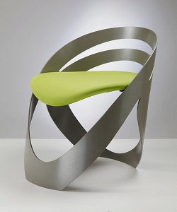

Modern Chair

$62.22

Availability: In stock

Description

This Helsingr Chair with its fun and colorful design will brighten up any room. Upholstered in a patched polyester, this versatile lounge chair can be used as part of a living room seating arrangement or as an accent piece in a bedroom.